



Car Price Prediction

LAB MANUAL

Disclaimer: The content is curated from online/offline resources and used for educational purpose only
Car Price Prediction using FNN

Objective:
To develop a Feedforward Neural Network (FNN) that accurately predicts car prices based on various numerical and categorical attributes such as brand, fuel type, engine size, mileage, transmission type, and more. This model will assist in understanding the influence of different features on car pricing and support better decision-making in the automotive market.

Problem Statement:
Predicting the market price of a car is a complex task influenced by numerous variables. Manual estimation often lacks precision and consistency. This lab activity focuses on building a supervised machine learning model using a Feedforward Neural Network (FNN) to learn from historical car data and estimate car prices. The task involves loading and preprocessing a dataset with both numerical and categorical features, encoding necessary variables, normalizing input values, and training the FNN. The model's performance will be evaluated using appropriate regression metrics. The ultimate goal is to deliver a model that can predict car prices with high accuracy, aiding buyers, sellers, and dealers in price estimation and market analysis.

Equipment Required:
- Python installed with Jupyter Notebook / VS Code / Google Colab
- Libraries: pandas, numpy, matplotlib, seaborn, scikit-learn, tensorflow or keras

Prerequisites:
- Basic knowledge of Python
- Understanding of TensorFlow and Keras
- Familiarity with model training, and evaluation

Procedure:
Step 1: Data Loading
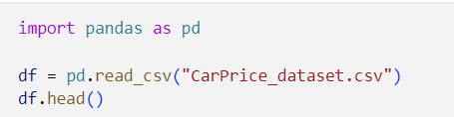

Step 2: Data Cleaning
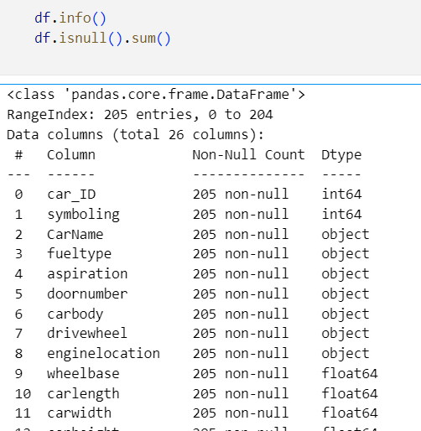

Step 3: Data Preprocessing and split the data
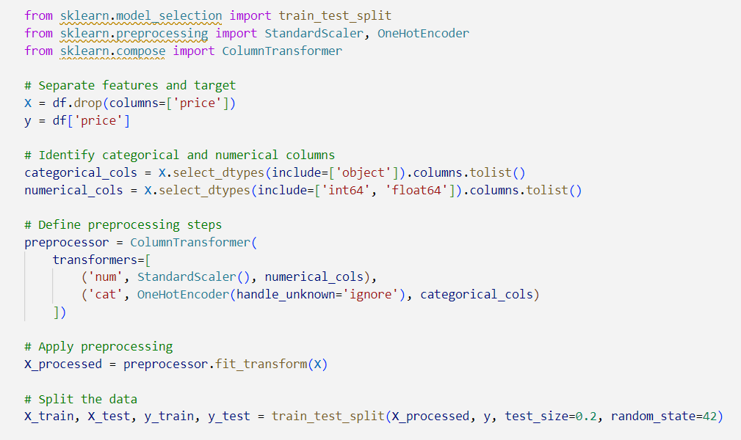

Step 4: Building Model
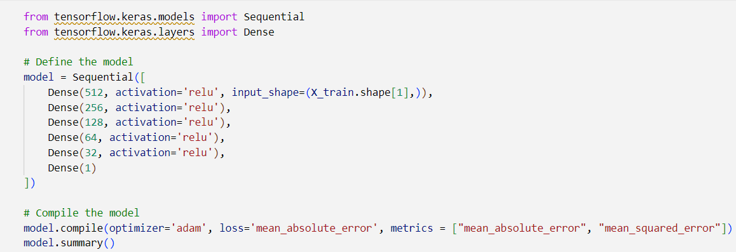

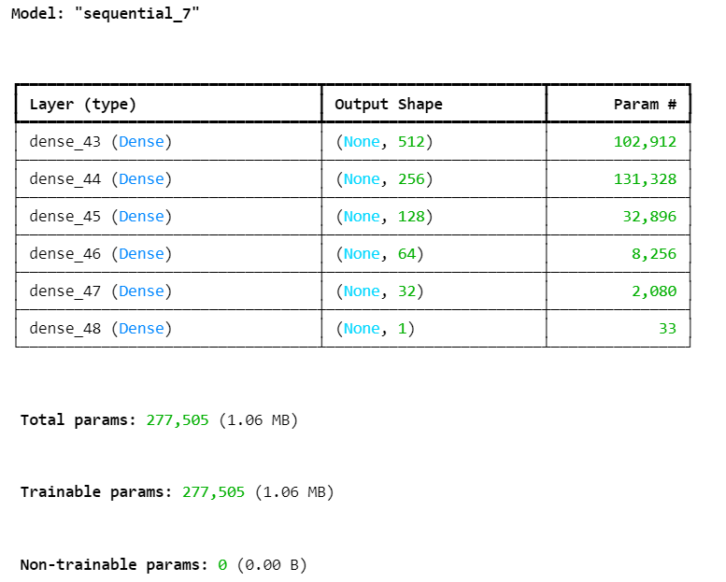

Step 5: Training the model
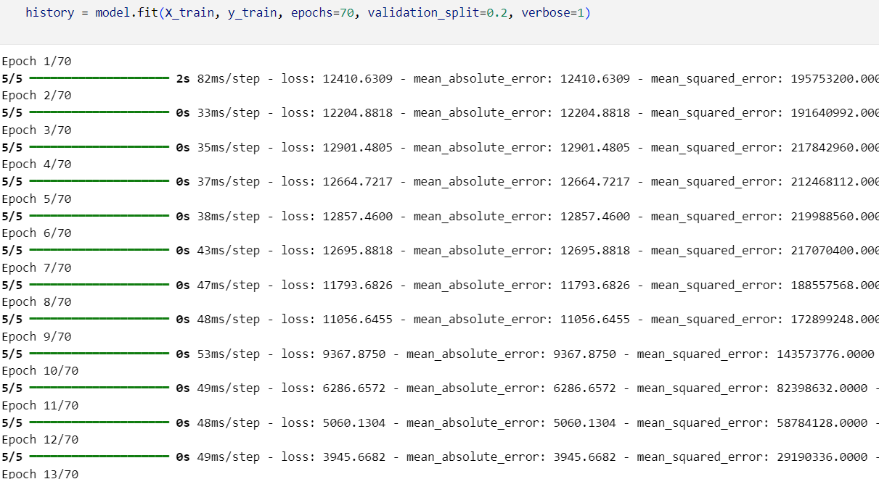

Step 6: Model evaluation
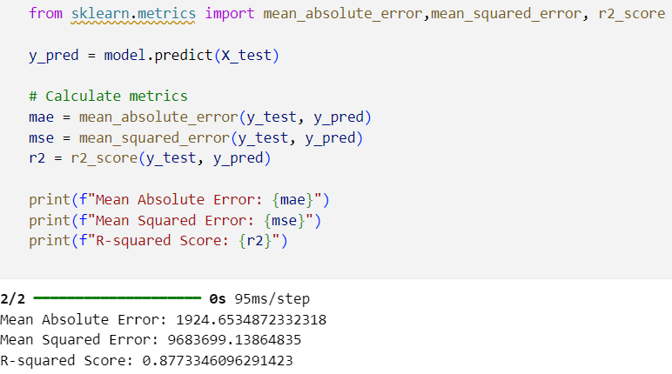

Step 7: Prediction on new data
